Module 11.1 – Milestone #3
Case Study: Bacchus Winery
Group 3
Members: James Buzzell, Noor Al Salihi, Abram Denzlinger

Report 1: Total Sales by Customer
This report displays the total sales amount for each customer. This is the sum of the line totals for each order belonging to a customer. The report is helpful for Bacchus Winery to determine who their top customers are and which customers produce the most revenue. The business can use this to assist in marketing and customer retention, and distributor relationships.
Python Script:
import mysql.connector
db = mysql.connector.connect(
host='localhost',
user='root',
password='classmate password',
database='team3_bacchus'
)
cursor = db.cursor()
query = '''
SELECT c.customer_name,
SUM(oi.line_total) AS total_sales
FROM Customer c
JOIN Orders o ON c.customer_id = o.customer_id
JOIN Order_Items oi ON o.order_id = oi.order_id
GROUP BY c.customer_name
ORDER BY total_sales DESC;
'''
cursor.execute(query)
results = cursor.fetchall()
print('TOTAL SALES BY CUSTOMER')
for row in results:
print(row)
db.close()

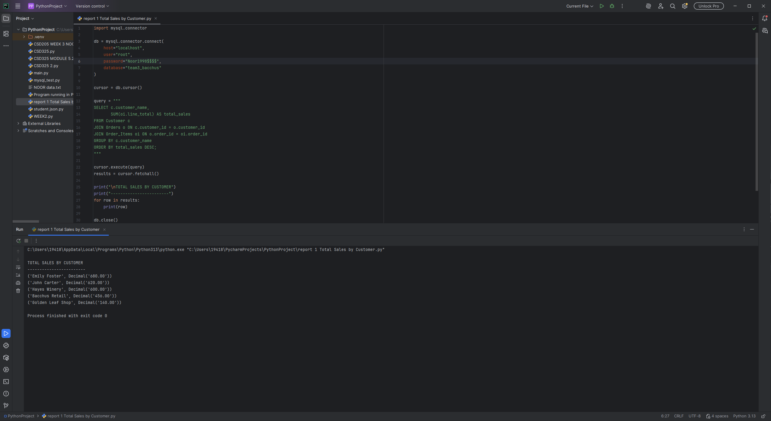

Report 2: Inventory Levels by Supplier
This report lists inventory materials broken down by supplier with item names, quantities on hand, and unit prices. Bacchus Winery can track inventory on hand and see which supplier the material comes from. The report could be used for purchasing purposes as well as to help keep the inventory from being under or over stocked.
Python Script:
import mysql.connector
db = mysql.connector.connect(
host='localhost',
user='root',
password='classmate password',
database='team3_bacchus'
)
cursor = db.cursor()
query = '''
SELECT s.supplier_name,
i.item_name,
i.quantity,
i.unit_price
FROM Inventory i
JOIN Supplier s ON i.supplier_id = s.supplier_id
ORDER BY s.supplier_name;
'''
cursor.execute(query)
results = cursor.fetchall()
print('INVENTORY LEVELS BY SUPPLIER')
for row in results:
print(row)
db.close()
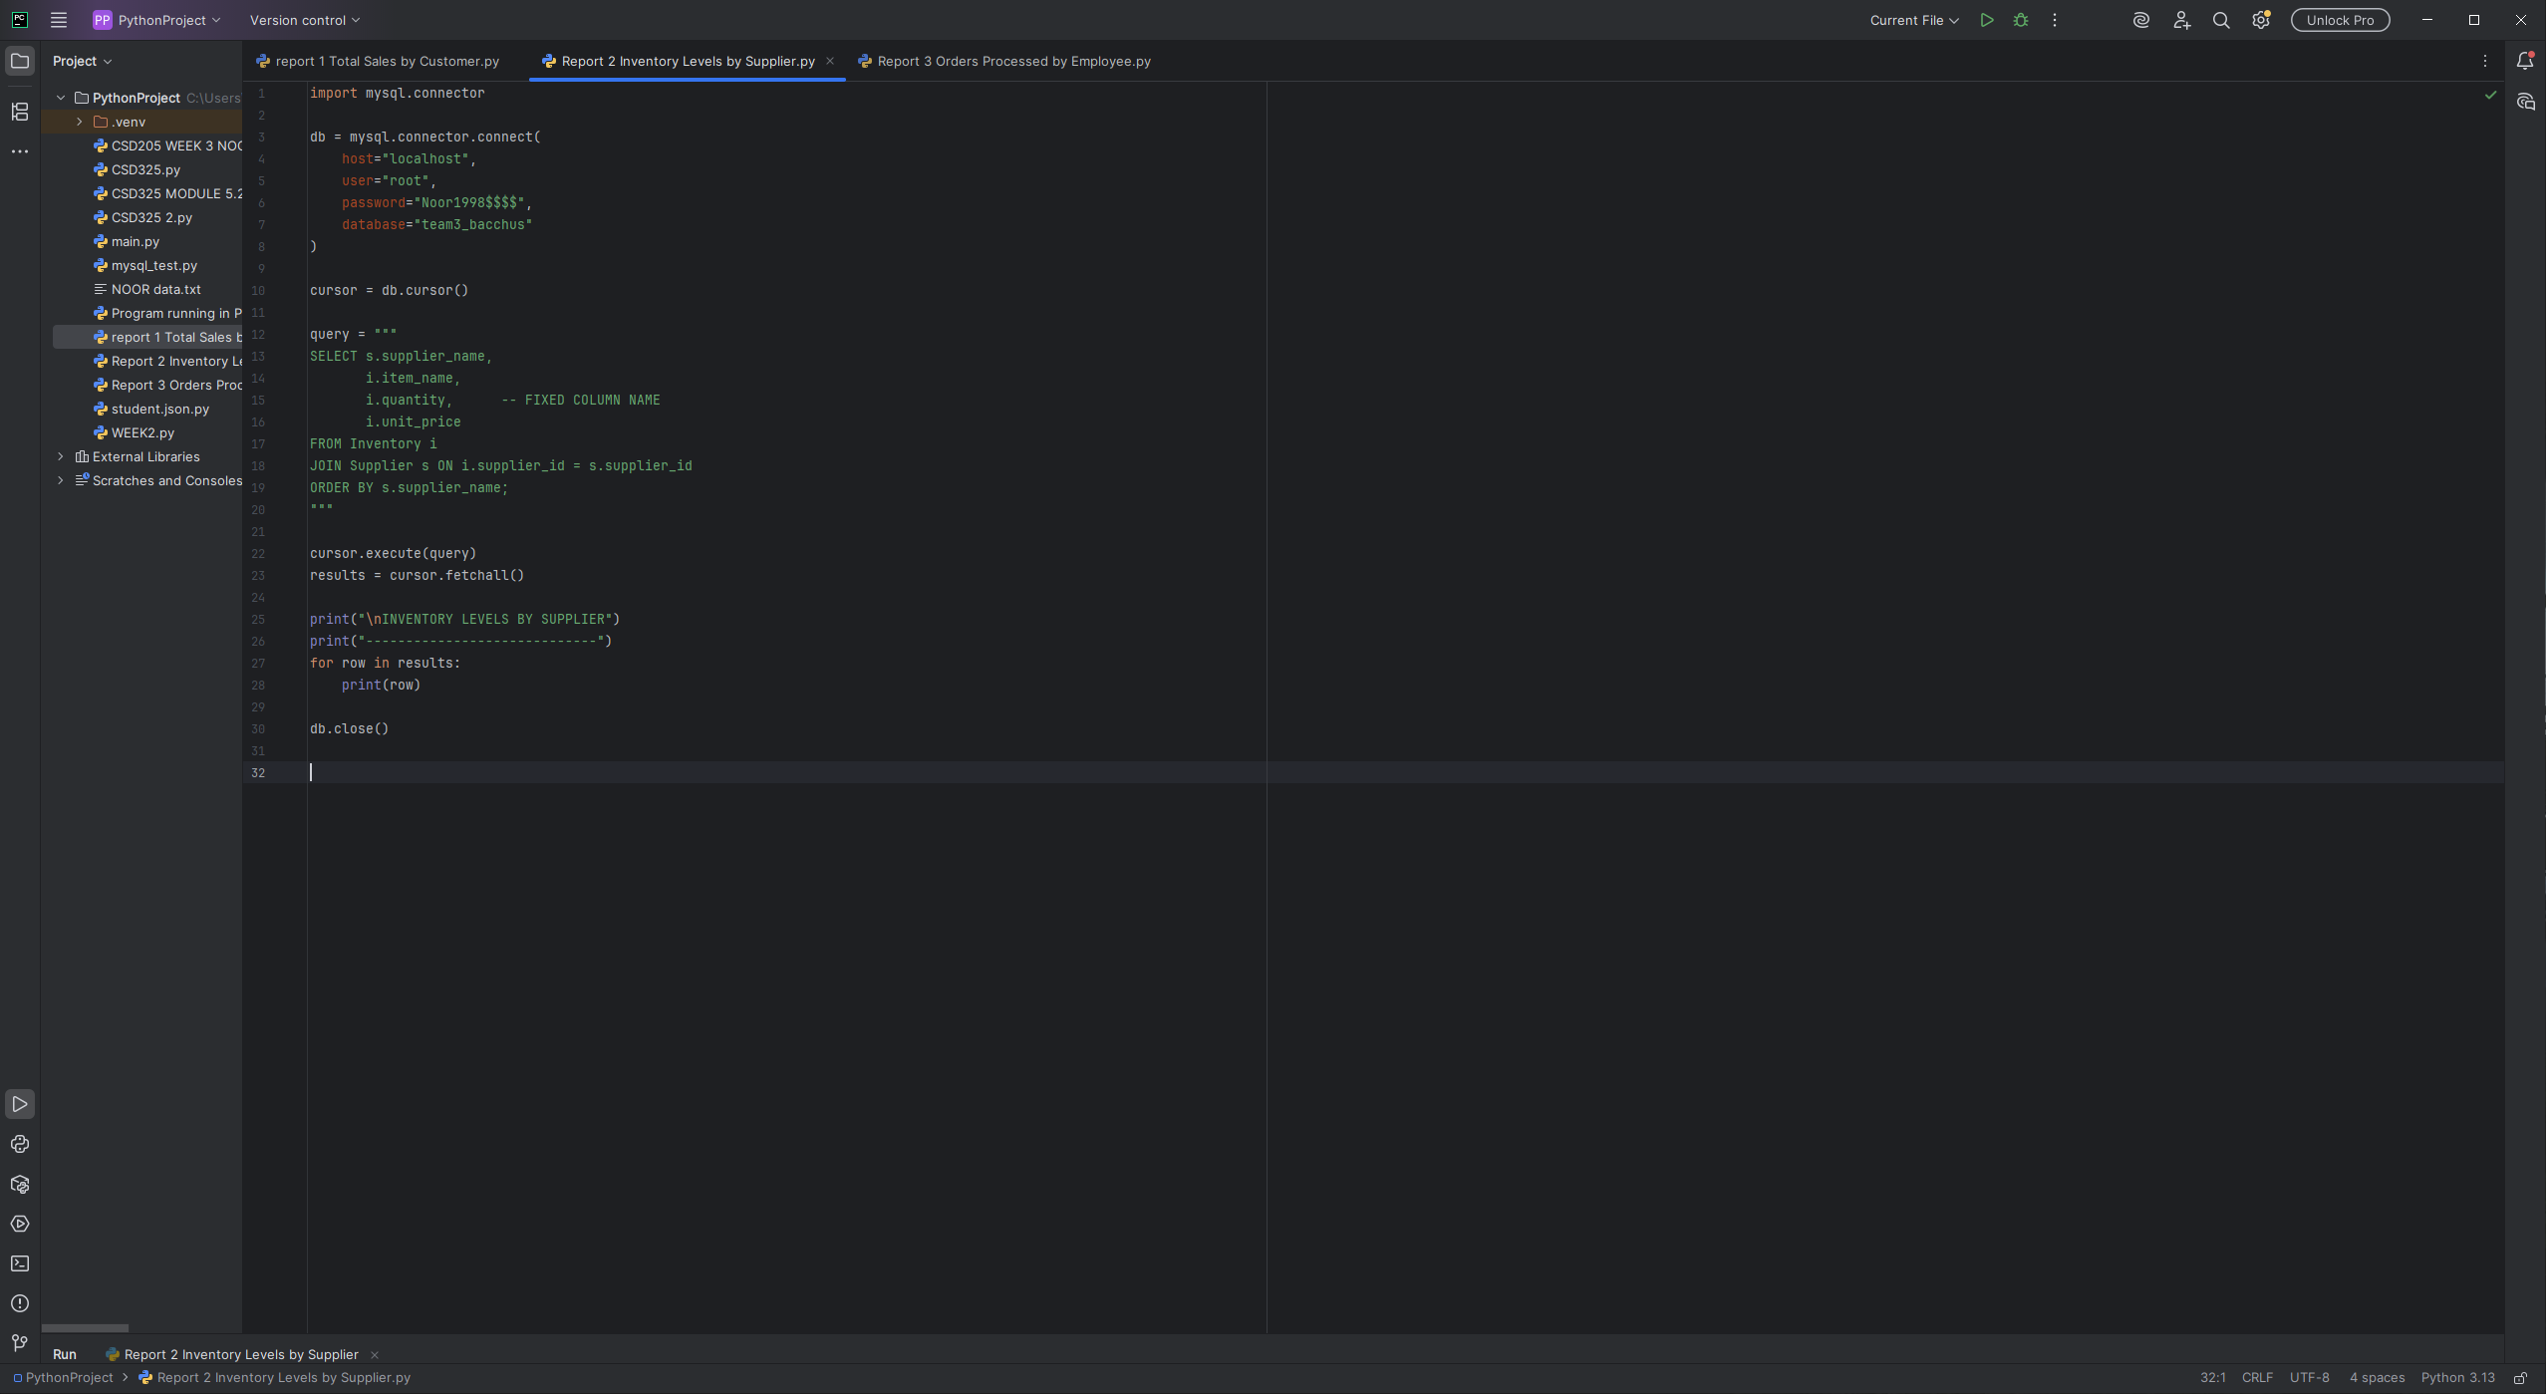

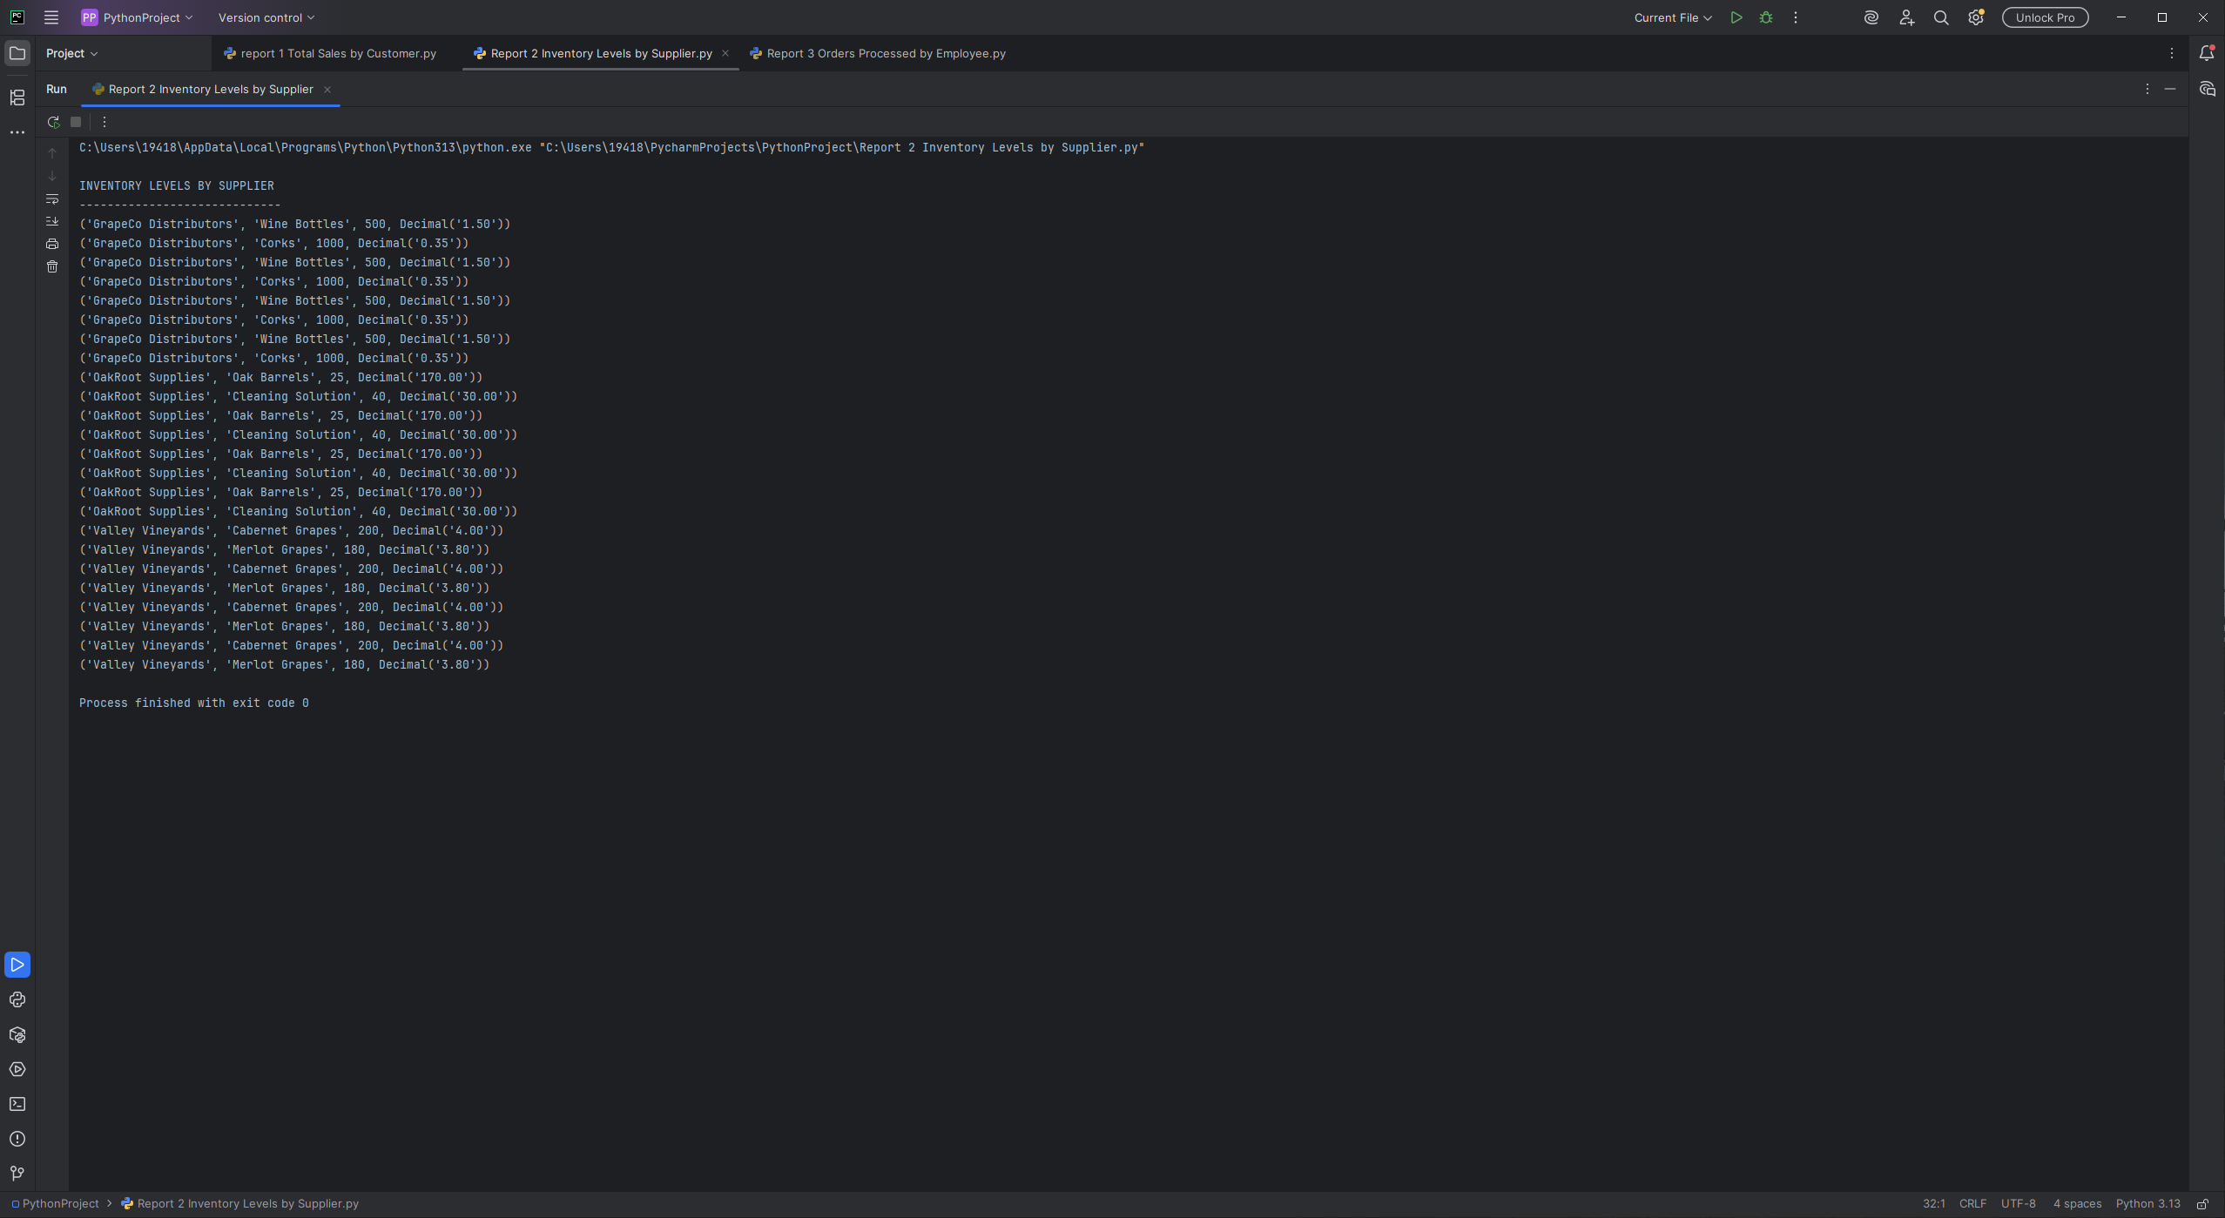

Report 3: Orders Processed by Employee
The purpose of this report is to list the number of orders that are processed by each employee. This report can be used by management to review employees to determine workload and productivity. The winery can balance the staffing needs of the business and provide recognition to those that process higher volumes of orders.
Python Script:
import mysql.connector
db = mysql.connector.connect(
host='localhost',
user='root',
password='classmate password',
database='team3_bacchus'
)
cursor = db.cursor()
query = '''
SELECT CONCAT(e.first_name, ' ', e.last_name) AS employee_name,
COUNT(o.order_id) AS orders_processed
FROM Employee e
LEFT JOIN Orders o ON e.employee_id = o.employee_id
GROUP BY employee_name
ORDER BY orders_processed DESC;
'''
cursor.execute(query)
results = cursor.fetchall()
print('ORDERS PROCESSED BY EMPLOYEE')
for row in results:
print(row)
db.close()
